**Coding Challenge Java**

**Hospital Management System**

**Output Screenshots**

Database before doing changes:

Table Patient

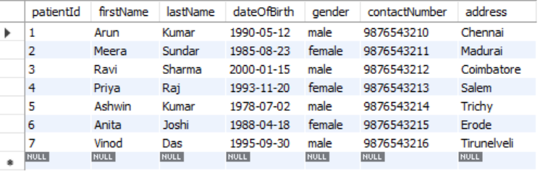

Table Doctor

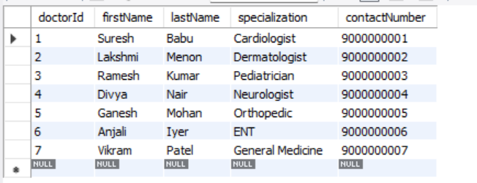

Table Appointment

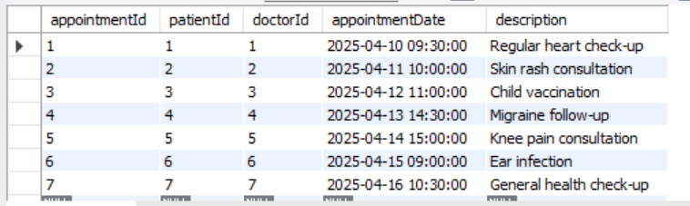

1. Get Appointment by ID

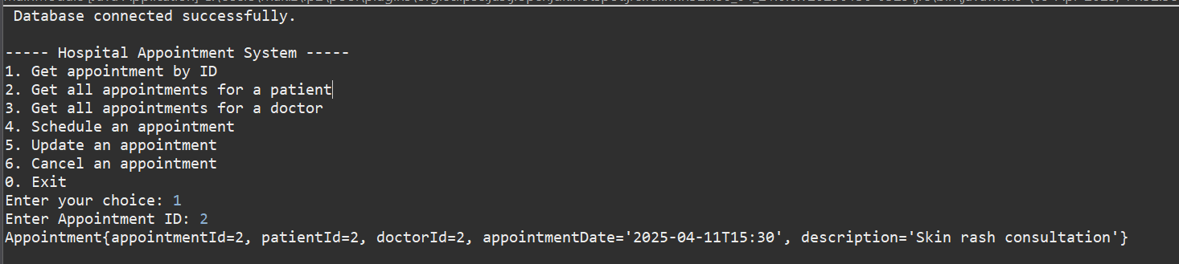

2) Get all appointments for a patient

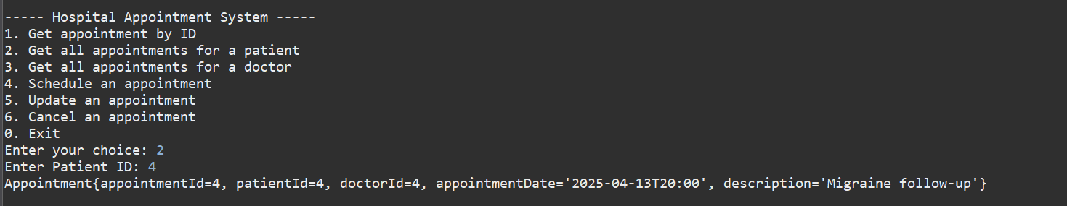

**3)** Get all appointments for a doctor

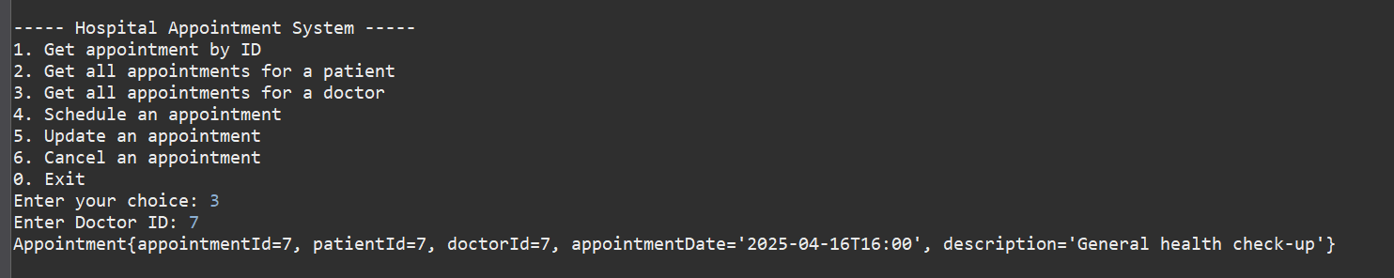

4) Schedule an appointment

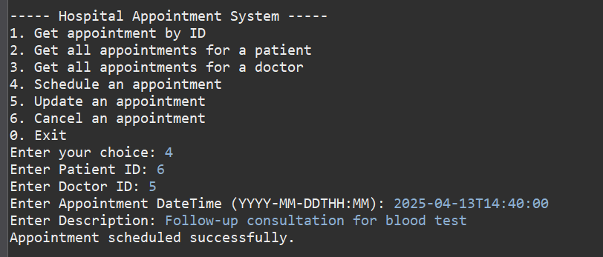

5) Update an appointment

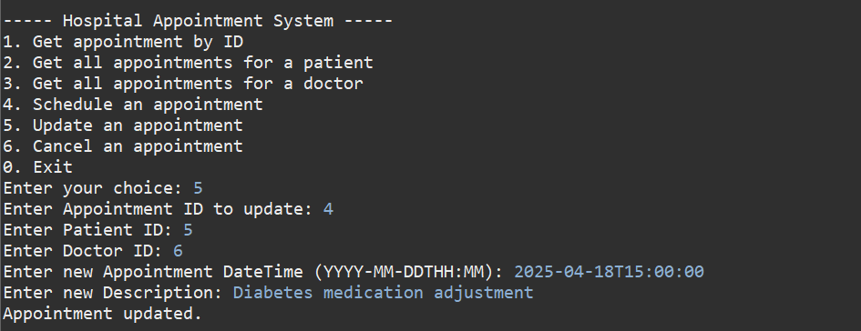

6) Cancel an appointment

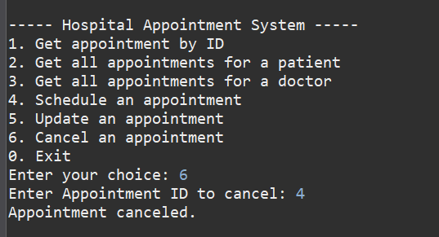

Database after performing the above changes

Table Appointment

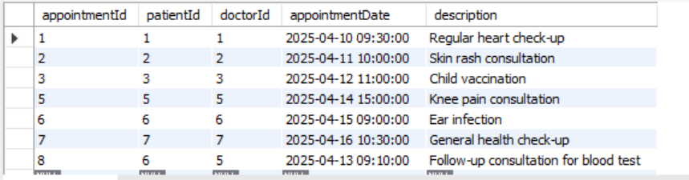

Table Doctor

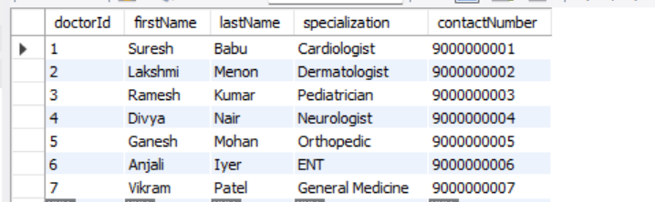

Table Patient

